Required for September 2022
LEAD TEACHER FOR PSHE
(Suitable for experienced teachers plus a TLR 2b, £4733)

We are seeking to appoint a committed, dynamic colleague who has the ability to work alongside a team of well-qualified, dedicated teachers in a 'Good’ school where behaviour is ‘exemplary’ (Ofsted, 2018). Our results and standards are excellent and we are the highest performing school in Cannock and Rugeley for Key Stage 4 Progress (DfE Performance Tables). This post marks an exciting new direction for our approach to teaching PSHE as we move towards a model of all students at KS3 benefitting from a discrete lesson of PSHE per week. This is in addition to our existing provision for KS4 students who have PSHE as part of their weekly tutor sessions. If you are successful, you will teach PSHE and lead it at a whole-school level from year 7 to year 11.

You will:
• be a strong, committed and reflective teacher;
• be innovative and creative in relation to planning and implementing a curriculum;
• have experience in raising student achievement and implementing effective intervention;
• have excellent interpersonal and communication skills;
• be aware of the new changes in the PSHE/RSE curriculum, and have ideas of how to implement this;
• be committed to maintaining the high standard of teaching that is already embedded within school.
We will be:
• a welcoming and supportive team;
• an excellent provider of career development and challenge, with excellent CPD opportunities;
• at the cutting edge of learning and teaching, as we develop our school and our curriculum.

Cannock Chase High School is an 11–19 mixed comprehensive school with around 1000 students on roll. Students and staff are warm, open and supportive to one another and proud of their school. We were judged as 'good' in our most recent Ofsted inspection and behaviour was described as 'exemplary'. Mutual respect is a key feature of our relationships here. We are currently experiencing high levels of success, with over 30% of our Sixth Formers going to Russell Group universities, including The University of Oxford.

Please refer to the following documentation, when completing an application for this post:
- Application Guidance Notes;
- Job Description and Person Specification.

A successful application will include:
- A completed School Application Form;
- A Letter of Application (of no more than two sides of A4), outlining how your skills and experience to date meet the requirements of this post.

Cannock Chase High School is committed to safeguarding and promoting the welfare of young people. All appointments are subject to an enhanced Disclosure and Barring Service (DBS) clearance.

The job description and person specification are available from the Headteacher at the school or via the website: www.cannockchasehigh.com/Jobs-at-CCHS. All applications must be on the school Application Form (which is also available from the school or via the website), CVs alone are not acceptable. Completed applications are to be e-mailed to Iain Turnbull, Headteacher, at headteacher@cannockchase-high.staffs.sch.uk.

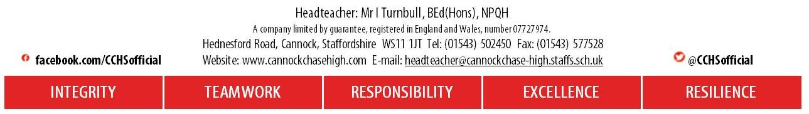
Closing date: Monday 31st January (3:30pm).

