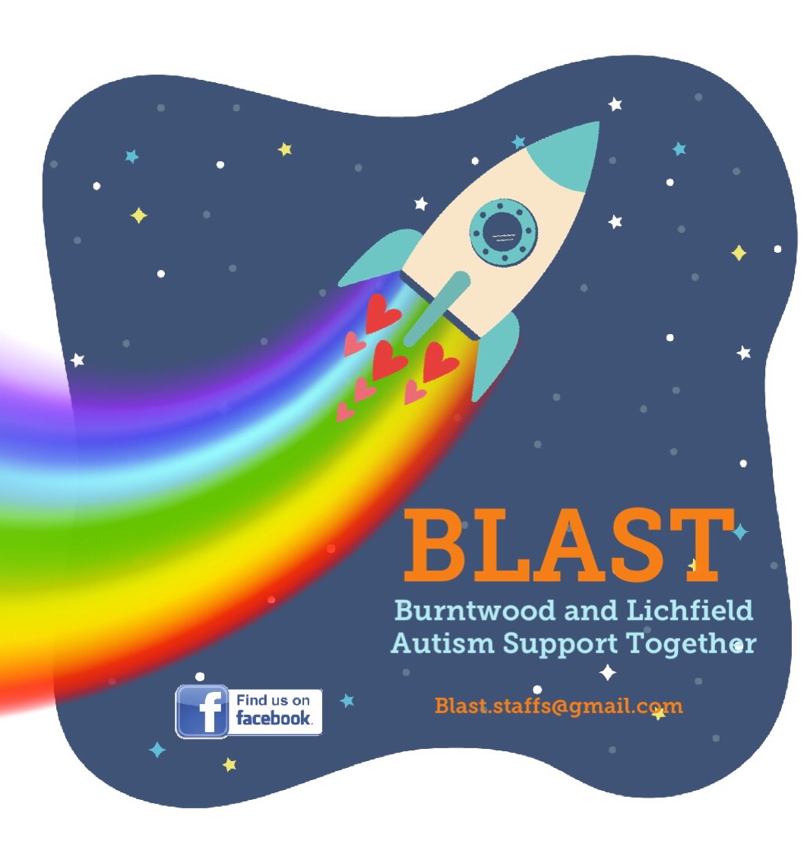

4 March 2019

Dear Parent

We are inviting parents to the launch meeting of an exciting new group covering Burntwood, Lichfield and surrounding areas.

For some time there has been a need for local opportunities for families in this area who live with Autism. The group aims to give parents the chance to connect, share information and help each other navigate the challenges of raising a child with autism in a neurotypical world.

We would love to see you on March 21st to gather your views and share our ambitious ideas for the group. BLAST will be held weekly on Thursday afternoons at Burntwood Library. We have some awesome invited speakers lined up for future meetings and will be covering topics such as sensory processing, the EHCP process, speech and language therapy, transitions, homework and wellbeing. Further details will be announced at our launch.

The group is free but we need parents to register and tell us if they can attend the launch meeting by emailing blast.staffs@gmail.com.

There is a Facebook page where parents can share local information, links and ideas as well as a closed Facebook group for parents who have registered with us.

We would like to thank Autism Outreach and Staffordshire Libraries for their support of this group and look forward to see as many parents as possible on 21st!

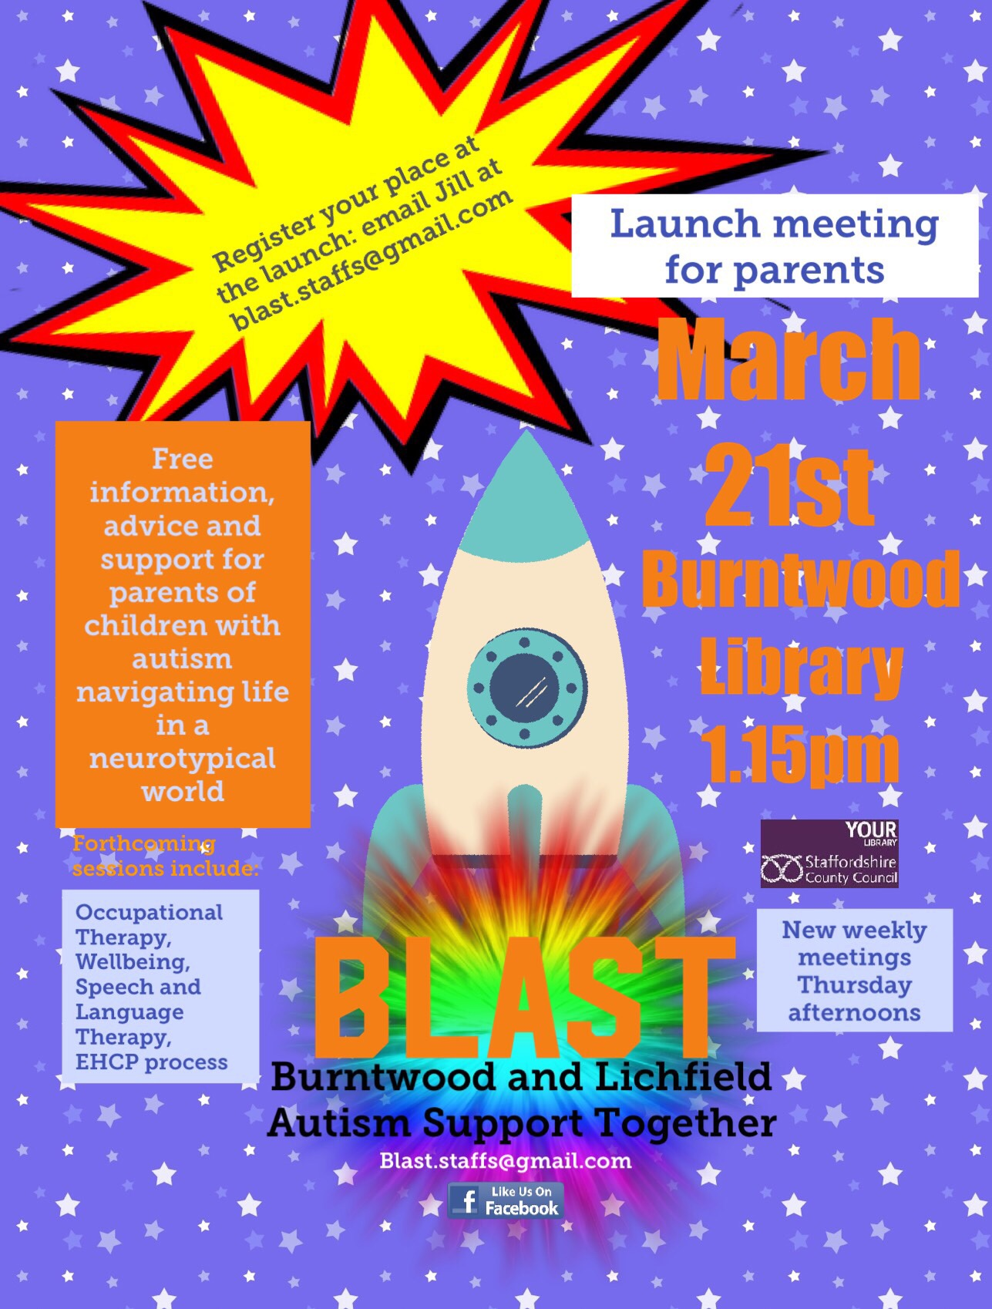

Jill Hart-Sanderson

