Cannock Chase High School

Local Government Pension Scheme

Employer Discretions – Compulsory Policy Statements

This document outlines Cannock Chase High School’s policy on the employer discretions specified in the Local Government Pension Scheme Regulations 2013, which come into effect from 1 April 2014.

Background Regulations
- Local Government Pension Scheme Regulations 2013 (LGPS 2013)
- Local Government Pension Scheme (Transitional Provisions, savings and Amendment) Regulations 2014 (TP 2014)

Areas of Discretion
There are 5 areas of discretion where a Scheme Employer must publish a policy by 30 June 2014 under Regulation 60 of LGPS 2013 and TP 2014.

- Regulation 16 LGPS 2013 (funding of additional pension)
- Regulation 30(6) LGPS 2013 (Flexible Retirement)
- Regulation 30(8) LGPS 2013 (waiving of actuarial reduction included with
- Regulation 30(6) Regulation 31 LGPS 2013 (award of additional pension)
- Schedule 2 TP 2014 (application of Rule of 85)

In addition this document details the Academy’s policy for the allocation of LGPS employee contribution bands and the Scheme of Delegation for decision making powers.

Regulation 16 LGPS 2013: Funding of Additional Pension

A Scheme member can “buy” an additional annual pension benefit (currently £6500 per year for 2014/2015) to enhance their benefits, to replace lost pension caused by a period of authorised absence or industrial dispute. The member can “buy” the additional pension either over a period of time or by a one off lump sum payment.

Where the pension has been lost because of a period of authorised unpaid absence, including child related absence the regulations require the employer to contribute to the cost of the lost pension where the member elects to “buy” back the lost pension within 30 days of returning to work. The employer contributes 2/3rds of the total cost and the employee 1/3 of the total cost. The cost is calculated in accordance with guidance provided by the Government Actuary (GAD).

Where the absence has occurred in consequence of a trade dispute the employer is not required to share the cost of the lost pension and there are no time limits as to when the employee can elect to “buy back” the lost pension.

Where the employer does not receive an election form from the employee within 30 days of returning to work from an authorised absence on no pay the Scheme employer may extend the period by which they will accept an election beyond the 30 day deadline.

The additional pension may be funded in whole or in part by the Scheme employer.

Discretions
1. Whether to extend the 30 day deadline for a member to elect to “buy” back the lost pension in respect of an unpaid period of authorised absence.

2. Whether Cannock Chase High School as the Scheme employer will contribute towards the cost of “buying” additional pension for a Scheme member to enhance their pension benefits.

Policy

Where a Scheme member makes an election after the 30 day deadline to “buy” back an amount of lost pension, as a result of unpaid authorised absence, and it can be demonstrated that the reason for missing the deadline was because the member was not informed by Cannock Chase High School that this deadline existed, Cannock Chase High School as a Scheme employer will accept a late election up to 30 days after the receipt of the first Annual Benefit statement received by the member, following the employees return to work from the period of unpaid authorised absence.

Cannock Chase High School as a Scheme employer will only contribute to the cost of ”buying” additional pension where the Scheme member is “buying” additional pension in respect of a period of authorised absence where an election form was received from the Scheme member within 30 days of returning to work.

Regulation 16 (2)(e ) and 16(4)(d). Additional pension contributions

Discretions

This regulation allows Cannock Chase High School to fund employees additional pension
contributions (in whole or in part). However funding additional pension contributions for employees would incur considerable costs for the Academy.

Policy

Cannock Chase High School will not fund in whole or in part employees additional pension contributions.

Regulation 30(6) LGPS 2013: Flexible Retirement

A Scheme employer has the discretion to allow flexible retirement for an employee age 55 or over who with the employer’s consent reduces their hours or grade. If an employer chooses to exercise this discretion, all or part of the accrued benefits can be paid even though the person remains in employment. Benefits will be reduced on account of early payment (subject to certain protections for pre 1 April 2014 members).

Where the Scheme employer permits flexible retirement the member must take all of the benefits built up prior to 31 March 2008.

Discretions
Whether to permit flexible retirement for staff age 55 or over, who with the agreement of Cannock Chase High School as a Scheme employer, are permitted to reduce their working hours or grade.

Whether to permit the member to draw:

- all part or none of the pension benefits built up after 31 March 2008 and before 1 April 2014 and/or
- all part or none of the pension benefits built up after 31 March 2014

Whether the Scheme employer, will agree to waive in whole or in part any actuarial reduction which would otherwise be applied to the benefits taken on flexible retirement before Normal Pension Age.

Policy

That Cannock Chase High School as employing authority will consider an application received in writing from a Scheme member to elect for flexible retirement under Regulation 30(6). Each case will be considered by the Cannock Chase High School on its merits and will be subject to the approval of the relevant Manager under the Cannock Chase High School’s Scheme of delegation, and in giving that approval they are satisfied that:

- There are no pension costs to the Academy arising form the employee's flexible retirement.

- There is an operational, business or financial case for permitting flexible retirement which will not result in any detriment to the level of service.

- A reduction to the total costs of employing the person of at least 40%.

- Any agreed change to the employee's contract under this policy will be a permanent change to their contractual terms and conditions.

- Where a request for release of retirement benefits under this provision has been refused, no further application under the provision may be considered until the following financial year.

Regulation 30(8)

The Academy will not waive in whole or in part any reduction applied to individuals drawing their pension benefits before their normal retirement age under regulations 30(5) or 30(6).

Regulation 31 LGPS 2013: Power of the employing authority to award additional pension to active members

A Scheme employer may resolve to award an active member or a member who was an active member who was dismissed by reason of redundancy or business efficiency or whose employment was terminated by mutual consent on grounds of business efficiency additional annual pension.

Discretions

Active member who was dismissed by reason of redundancy

The Academy as the Scheme employer will exercise this discretion where an active LGPS member is dismissed on the grounds of redundancy under regulation 30(7) of LGPS 2013 and where that person is entitled to a redundancy payment.

Where an employee of Cannock Chase High School as employing authority is dismissed on the grounds of redundancy and qualifies for a statutory redundancy payment they will award lump sum compensation under the Local Government (Early Termination of Employment) (Discretionary Compensation) (England and Wales) Regulations 2006.

At the member's request, the Cannock Chase High School will, as an alternative to this compensation payment, allow the member to receive additional annual pension under Regulation 31 of the LGPS 2013 which will be assessed having regard to the capital value of the lump sum compensation otherwise payable, and in accordance with factors supplied by the Fund Actuary.

Active members and active members dismissed by reason of business efficiency or whose employment was terminated by mutual consent on grounds of business efficiency additional annual pension.

At this time, the Academy will not normally use this power in any other circumstances.

Regulation 30 LGPS 2013: Early retirement after age 55 before Normal Pension Age (NPA) where employment ceases on or after 1 April 2014
Background

- A Scheme member who leaves their employment after 1 April 2014 and has attained age 55 or more can elect to receive their pension benefits immediately under Regulation 30(5).
- A former employee, who ceased their employment and Scheme membership after 1 April 2014 without entitlement to immediate payment of benefits, attains age 55 they can elect for their deferred benefit to be brought into payment before NPA.
- A former employee who ceased their employment and Scheme membership after 1 April 2014 with a Tier 3 Ill health benefit which has ceased to be paid (paid for a maximum of 3 years), attains age 55 they can elect for their deferred benefit to be brought into payment before NPA.

Discretions

1. Where an election is received under Regulation 31 Cannock Chase High School as a Scheme Employer can exercise their discretion as to whether to waive all or part of any actuarial reduction (on compassionate or other grounds) that would apply to the member’s pension benefits under Regulation 30(8) of LGPS Regulations 2013.

2. Where an election is received under Regulation 31 Cannock Chase High School as a Scheme Employer can exercise their discretion as to whether to apply the “Rule of 85” protections to “relevant employees” under Schedule 2 of TP 2014.

Areas of Discretion that a Scheme Employer can exercise in relation to 1 and 2 above.
Where an employee or former employee was not a Scheme member before 1 October 2006

Whether to,

- waive on compassionate grounds, any actuarial reduction that would be applied to benefits built up before 1 April 2014 and/or;
- waive, in whole or in part (on any grounds), any actuarial reduction that would be applied to benefits built up after 31 March 2014.
Where an employee or former employee was a Scheme member before 1 October 2006 and will be 60 or more on 31 March 2016.
Whether to,

- waive on compassionate grounds, any actuarial reduction that would be applied to benefits built up before 1 April 2016 and/or;
- waive, in whole or in part (on any grounds), any actuarial reduction that would be applied to benefits built up after 31 March 2016.

Where an employee or former employee was a Scheme member before 1 October 2006 and will not be age 60 or more on 31 March 2016 and will not attain age 60 between 1 April 2016 and 31 March 2020.
Whether to,

- waive on compassionate grounds, any actuarial reduction that would be applied to benefits built up before 1 April 2014 and/or;
- waive, in whole or in part (on any grounds), any actuarial reduction that would be applied to benefits built up after 31 March 2014.

Where an employee or former employee was a Scheme member before 1 October 2006 and will not be 60 or more on 31 March 2016 but will attain age 60 between 1 April 2016 and 31 March 2020
Whether to,

- waive on compassionate grounds, any actuarial reduction that would be applied to benefits built up before 1 April 2020 and/or;
- waive, in whole or in part (on any grounds), any actuarial reduction that would be applied to benefits built up after 31 March 2020.

Regulation 30(8) – Waiving of actuarial reduction

Policy
The Academy will not waive in whole or in part any reduction applied to individuals drawing their pension benefits before their normal retirement age under schedule 2 2(1).

Rule of 85 protections
The Academy will not allow the rule of 85 protections to apply.
Cannock Chase High School policy for the allocation of LGPS employee contribution bands
Members of the Local Government Pension Scheme (LGPS) will be assigned to the relevant contribution band for the year 2014/15 based upon the pensionable pay that they earned in 2013/14. For employees who did not work for the whole of that year, the relevant LGPS contribution band will be allocated based upon their annual salary rate.

The Academy’s policy is to set contribution rates based on actual pay as at 1 April each year and not to make any changes during the year, except in the following circumstances:
- pay is permanently reduced, such that it would cause a move to a lower band
- pay is permanently increased, such that it would cause a move to a higher band
- a contractual additional payment is applied that would cause a move to a higher band
In all other circumstances assessment will be made on the actual pay at the end of March each year.

Cannock Chase High School
Scheme of Delegation for LGPS
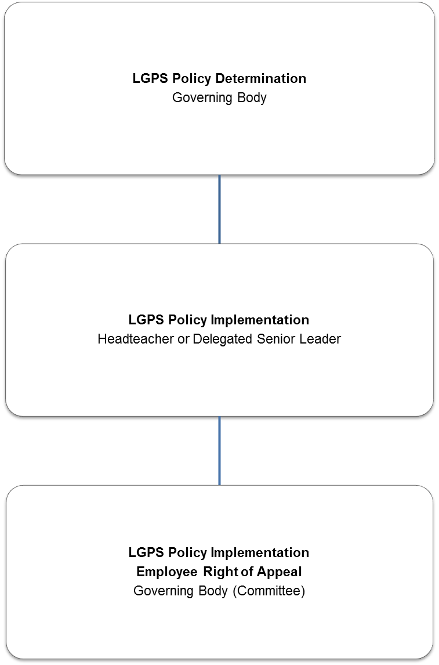

This Scheme of Delegation is subject to review every 3 years or at the point of statutory, regulatory or organisational change.

