KEY STAGE 4 STANDARDS
2018 Key Stage 4 Outcomes
Data based on ‘best entry’ outcomes, compared against provisional 2018 DfE estimates.
Headlines will be updated in 2019 following the publication of the amended and validated 2018 national estimates.

CONTEXT

On 29 September 2013 the Secretary of State announced that, from this date, only a student’s first entry to a Key Stage 4 qualification counts towards their school’s performance measures. Students can sit an examination more than once but it will be their first certificated grade in that subject that will be used for performance measures. As a school we feel that a decision to remove the opportunity for all students to sit an examination early would be to some students’ detriment, as many gain confidence and build upon their successes as they re-sit examinations. It can also take added pressure off their performance in the summer of Year 11, as they may already have achieved their target grade and can, therefore, work on getting their best grade with less stress and anxiety, which in turn will lead to a better performance for them. For other students, however, sitting an examination too early when they are not fully equipped could reduce their confidence and add to the anxiety that external examinations can cause. Therefore, through rigorous tracking of students’ progress and dialogue with teachers and parents throughout Year 9 and Year 10 we are able to make an informed decision as to which students we think early entry will best suit.

The implications of this decision will be felt by the school in our ‘league table’ data. Students who sit examinations early will want to re-sit to try to improve grades but this new grade will not be taken into account when the school’s data is calculated; thankfully it will still count for the student. We have been placed in a position whereby we have been forced to choose between what benefits the school’s data and what benefits our students. On this basis the decision was an easy one, as we will always prioritise the needs of our students and do what is in their best interests, irrespective of the impact on performance tables positions.

Therefore, the result shown on the following pages are our students’ ‘Best Entry’. This will allow all prospective parents and students to fully evaluate our school’s performance and for CCHS to be comparable with other schools. Please ignore League Table results that show ‘First Entry’ results when students were in Year 10.

PROGRESS 8

The Progress 8 measure is designed to encourage all students to study a broad and balanced curriculum. The new measure is based on students’ progress measured across eight subjects. For each student, the eight subjects must be the correct combination from the diagram below.

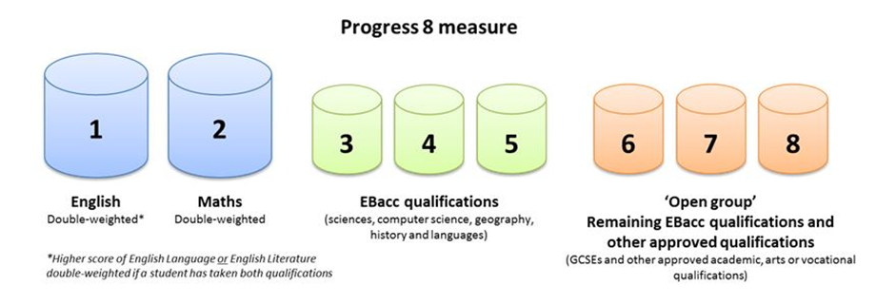

The Progress 8 score is determined by dividing the points total by 10 (the eight qualifications with English and Mathematics double counting) then calculating the difference between their estimated points (using Key Stage 2 SATs scores) and actual points. If they score ‘0’ then they achieved in line with expectations; if they achieve a positive score then they exceeded their expectations and so on.

 | CCHS 2016 | CCHS 2017 | CCHS 2018
Progress 8 | +0.180 | +0.140 | +0.002

The results show that, for the third consecutive year, CCHS has achieved a positive Progress 8 score, meaning that, on average, students are attaining grades that are above what would be expected of them if they were to be making nationally expected progress.

Cannock Chase High School is the only school in Cannock & Rugeley to achieve a positive Progress 8 score for three consecutive years.

BASICS MEASURE

The ‘Basics Measure’ indicates the attainment of students in English and Mathematics, irrespective of their Key Stage 2 start-point. Traditionally, this measure has indicated the percentage of students achieving A*-C grades. Following the reforms made to the grading system in 2017, this measure now indicates the percentage of students achieving grades 9-4 (standard pass) and grades 9-5 (strong pass) in English and Mathematics.

The system of comparable outcomes does mean that, relative to their start-point, the same proportion of students achieved grades 9-4 in 2017 as achieved grades A*-C in 2016. Therefore, historical data is comparable for the 9-4 measure, but not the 9-5.

 | CCHS 2016 | CCHS 2017 | CCHS 2018
% A*-C/9-4 in Eng/Maths | 51% | 60% | 59%
% 9-5 in Eng/Maths | - | 31% | 35%

AVERAGE TOTAL ATTAINMENT 8

The ‘Average Total Attainment 8’ measure indicates the average total of Attainment 8 points scored by a student, with each qualification grade being worth a particular number of Attainment 8 points.

Due to a change in methodology in 2017, the 2017 Average Total Attainment 8 points score is not comparable with historical data.

 | CCHS 2016  (not comparable to 2017 OR 2018 due to change in points methodology) | CCHS 2017 | CCHS 2018
Attainment 8 | 50.58 | 46.26 | 44.94

ENGLISH BACCALAUREATE

The English Baccalaureate (EBacc) is a suite of qualifications made up of English, Mathematics, History or Geography, the sciences and a language. From 2017, students who achieve the EBacc are those who have achieved the qualifications from the suite at grades C/5 or above.

At Cannock Chase High School, the opportunity has been and remains available to all students to study the EBacc suite of qualifications as part of the students’ Key Stage 4 curriculum, though historically only a small percentage of the cohort have opted to do so as part of the options process at the end of Key Stage 3.

 | CCHS 2016 | CCHS 2017 | CCHS 2018
% Entered for EBacc | 8.3% | 7.6% | 8.2%
% Achieved EBacc at grade C/4 or above (standard pass) | 4.7% | 6.3% | 6.2%
% Achieved EBacc at grade C/5 or above (strong pass) | - | 7.0% | 4.1%

PERFORMANCE OF DISADVANTAGED STUDENTS

 | 2017 Progress 8 | 2018 Progress 8
All students (inc PP) | 0.14 | 0.00
Non- PP Students | 0.20 | 0.15
Pupil Premium Students | 0.03 | -0.45

PERFORMANCE OF SEN STUDENTS

 | 2017 Progress 8 | 2018 Progress 8
All | 0.14 | 0.00
None SEN | 0.14 | 0.011
SEN Support | 0.06 | -0.1546
SEN Statement/EHCP | 0.48 | -0.720

