My Ref: JRS/CAG Your Ref: Date: 10 June 2015

Dear Parent/Guardian

In response to the vast amount of educational change in the way in which schools are being measured, I thought that I would take this opportunity to update you on how our school is responding to these changes in order to ensure that we continue to achieve the best results for all of our students.

First Entry Rule

On 29 September 2013 the Secretary of State announced that, from this date, only a student’s first entry to a key stage 4 qualification counts towards their school’s performance measures. Students can sit an examination more than once but it will be their first certificated grade in that subject that will be used for performance measures. As a school we feel that a decision to remove the opportunity for all students to sit an examination early would be to some student’s detriment, as many gain confidence and build upon their successes as they re-sit examinations. It can also take added pressure off their performance in the summer of Year 11, as they may already have achieved their target grade and can, therefore, work on getting their best grade with less stress and anxiety which in turn will lead to a better performance for them. For other students however, sitting an examination too early when they are not fully equipped could reduce their confidence and add to the anxiety that external examinations can cause. Therefore, through rigorous tracking of students’ progress and dialogue with teachers and parents throughout Years 9 and 10 we will be able to make an informed decision as to which students we think that early entry will best suit.

The implications of this decision will be felt by the school in our future ‘league table’ data. Students who sit examinations early will want to re-sit to try to improve grades, but this new grade will not be taken into account when the school’s data is calculated, thankfully it will still count for the student themselves. Therefore, we will publish a separate set of results showing our students ‘Best Entry’ in order for us to fully evaluate our own performance and to be comparable against other schools. We have been placed in a position whereby we have been forced to choose between what benefits the school’s data and what benefits our students. On this basis the decision was an easy one, as we will always prioritise the needs of our students.

Progress 8 and Attainment 8 Performance Measure

Currently all academies and schools are measured on how many GCSEs they achieve at A*-C including English and Mathematics. From 2016, all students and Academies will be measured on how much progress they make from when they start in Year 7 to when they complete their exams at the end of Year 11. This will be known as Progress 8.

In 2016 Progress 8 will be introduced for all. The Progress 8 measure is designed to encourage all students to study a broad and balanced curriculum. The new measure will be based on students’ progress measured across eight subjects. For each student the 8 subjects must be the correct combination from the diagram below.

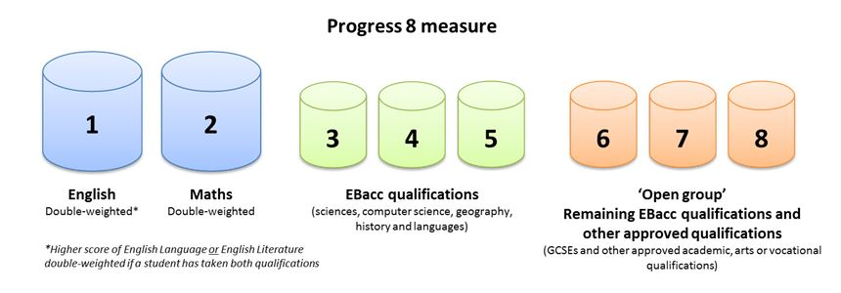
The Progress 8 score is determined by dividing the points total by 10 (the eight qualifications with English and Mathematics counting double) then calculating the difference between their estimated points (using key stage 2 SATs scores) and actual points. If they score ‘0’ then they achieved in line with expectations, if they achieve a positive score then they exceeded their expectations and so on. The Points are calculated as follows (although after 2016 results the points will be converted into a 1-9 scale to coincide with the new GCSE’s)

A* | A | B | C | D | E | F | G
8 | 7 | 6 | 5 | 4 | 3 | 2 | 1

Example student:
Basket | Qualification | Result | Points Score | Basket points Total  Calculating progress 8:  Estimated points = 48  Actual points = 50  Difference = +2  Divide by 10 =+0.2  Progress 8 = +0.2
Maths | Maths GCSE | D | 4 | 4 x 2 = 8
English | English Language GCSE | D | 4
 | English Literature GCSE | B | 6 | 6 x 2 = 12
EBacc | Core Science GCSE | B | 6 | 6+5+5 = 16
 | Geography GCSE | C | 5
 | GCSE French | C | 5
Other | GCSE PE | C | 5 | 5+4+5 = 14
 | GCSE Business Studies | D | 4
 | GCSE Drama | C | 5
 | Total |  |  | 50 points

The whole school progress 8 measure will then be calculated by adding all of our students progress 8 scores together. A positive score shows that a school achieves more than expected progress with students, it is shown as a grade equivalent. For example: a school Progress 8 score of +0.3 shows that on average the students in the school achieve 1/3 of a grade higher than expected.

As a school we welcome these new measures as they take into account the progress of every child and not just those students likely to get a ‘C’ grade, allowing us to fully embrace our ‘Achievement for All’ ethos. We feel that we have fully prepared our students for these changes through offering a broad and balanced curriculum to ensure that the students can succeed in all 8 areas of the progress measure.

We realise that these new measures can be confusing, therefore, we would like to invite you to attend a Progress 8 information evening on Thursday 18 June in Upper School to gain a better understanding of how it works and how it will affect your child, as well as information on the way in which we will be reporting on their progress over the next 12 months. There will be 3 short workshops taking place with plenty of opportunities for questions to be answered throughout, as well as the school Leadership Team being on hand to answer any follow up questions or concerns in the 6th Form Centre, where refreshments will also be available.

If you would like to attend the information evening, then please complete the slip below outlining which workshop you would like to attend. Additional information is also available on the school website under ‘Parents’. Should you require any further information or have any queries in relation to the new measures, please do not hesitate to get in touch.

Yours sincerely
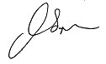
Miss J Simpson
Deputy Headteacher – Standards

Progress 8 Information Evening: 18 June 2015 - Reply slip

I would like to attend the Progress 8 information evening on Thursday 18 June. Please indicate below which workshop you would like to attend:

Workshop 1 - 5:00-:5:30 □
Workshop 2 - 5:40- 6:10 □
Workshop 3 - 6:20-6:50 □

The number of people attending on the evening:___________

Name of student: ____________________________________________ Year group: ______________

Name of parent/guardian:_____________________________ Signed: _______________________

